Year 11 Integrated Science ATAR

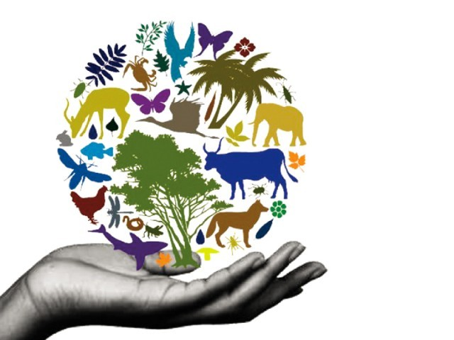Biodiversity Test

**Section A: Multiple Choice 10 marks**

Answer all questions on the separate answer sheet.

1. Which of the following regions would have the highest biodiversity?
2. a tropical rainforest in Queensland
3. a desert in Central North America
4. a rainforest in Indonesia
5. an Antarctic island
6. Which of the following terms is used to explain the discontinuity of native bush caused by land clearing.
7. Land degradation
8. Fragmentation
9. Farming
10. Deforestation
11. Complete the following sentence:

Biodiversity …

1. increases towards the equator.
2. decreases towards the equator.
3. remains the same throughout the planet.
4. increases only on small islands.
5. Which of the following statements is not correct about the impact of introduced species on the biodiversity of an ecosystem.
6. Increased competition for food and habitat
7. Increased predation
8. Increased reproduction for all species
9. Decreased species diversity
10. Species diversity in a habitat can be measured by counting the
11. total number of individuals.
12. total number of species.
13. number of species and relative abundance.
14. number of different ecosystems available.
15. Genetic diversity is best determined by looking at
16. the number of different species in the environment.
17. the risk of extinction of the species.
18. small variations within a species.
19. relative abundance of the species.
20. What is biodiversity?
21. The number of animals that live in a rainforest.
22. The rich variety of live organisms in every ecosystem on Earth.
23. The number of plants and animals that live in our backyards
24. The total number of organisms on the Earth.
25. The stability of an ecosystem is dependent on its
26. proximity to the equator.
27. exposure to extreme temperatures.
28. genetic biodiversity.
29. proximity to human settlements.
30. 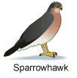What is wrong with the following food chain

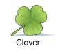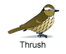



1. Hawks don’t eat Thrushes
2. Thrush’s are carnivorous
3. The clover should be at the start of food chain
4. Thrushes eat hawkes

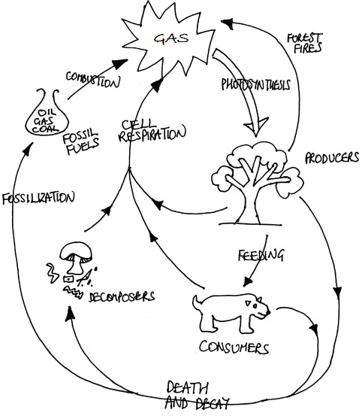

1. Which cycle is represented in the diagram above
2. Water cycle
3. Carbon cycle
4. Nitrogen cycle
5. Oxygen cycle

**Section B: Multiple Choice 43 marks**

1. What two processes must firstly be undertaken in order to determine the species diversity in an ecosystem? (2 marks)

_______________________________________________________________________________

1. The number of animal species in an ecosystem is dependent on the number of plant species. Explain why this is so? (4 marks)

____________________________________________________________________________________________________________________________________________________________________________________________________________________________________________________________________________________________________________________________________________________________

1. A horse and a donkey are able to interbreed to produce a mule, which is sterile.
2. Explain why the mule is sterile. (2 marks)

______________________________________________________________________________________________________________________________________________________________________________

1. State whether the mule can contribute to biodiversity, giving reason for your answer. (4 marks)

____________________________________________________________________________________________________________________________________________________________________________________________________________________________________________________________________________________________________________________________________________________________

1. Distinguish between genetic diversity and species diversity and explain the importance of both of these to the term “biodiversity”. (4 marks)

___________________________________________________________________________________________________________________________________________________________________________________________________________________________________________________________________________________________________________________________________________________________________________________________________________________________________________________

The diagram below shows part of the food web for Antarctica.

Use this food web to answer the following questions.

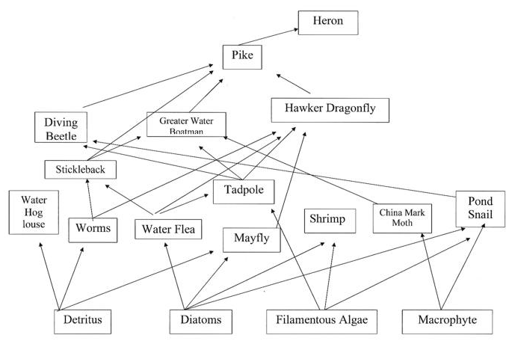

1. From the food web above name: (8 marks)
   * 1. one producer: ____________________________________________________________
     2. one herbivore: ___________________________________________________________
     3. two carnivores: ___________________________________________________________
2. Show a food chain that includes the following: (4 marks)
3. A Mayfly:
4. A Tadpole and a Pike:
5. When the population of one species changes, there are usually changes in other populations in the food web ecosystem. These changes can have a direct or indirect effect on populations in a food web.

If the population of Diving Beetle were to disappear from the ecosystem, which organisms are likely to increase in number and which are likely to decrease in number. (8 marks)

Population that would increase: ______________________________________________________________________________________________________________________________________________________________________________

Explanation: ____________________________________________________________________________________________________________________________________________________________________________________________________________________________________________________________________________________________________________________________________________________________

Population that would decrease: ______________________________________________________________________________________________________________________________________________________________________________

Explanation: ____________________________________________________________________________________________________________________________________________________________________________________________________________________________________________________________________________________________________________________________________________________________

1. Draw a labelled diagram of the water cycle showing the following – evaporation, precipitation, condensation, runoff, infiltration (7 marks)

**Biodiversity Test**

**Name: ____________________**

**Section A: Multiple Choice**

|  |  |  |  |  |
| --- | --- | --- | --- | --- |
| 1 | a | b | c | d |
| 2 | a | b | c | d |
| 3 | a | b | c | d |
| 4 | a | b | c | d |
| 5 | a | b | c | d |
| 6 | a | b | c | d |
| 7 | a | b | c | d |
| 8 | a | b | c | d |
| 9 | a | b | c | d |
| 10 | a | b | c | d |